Draw Global Execution Context for Below Codes and Explain Line by line.

console.log(a);  
var a = 10;  
console.log(a);  
a = 20;  
console.log(a);

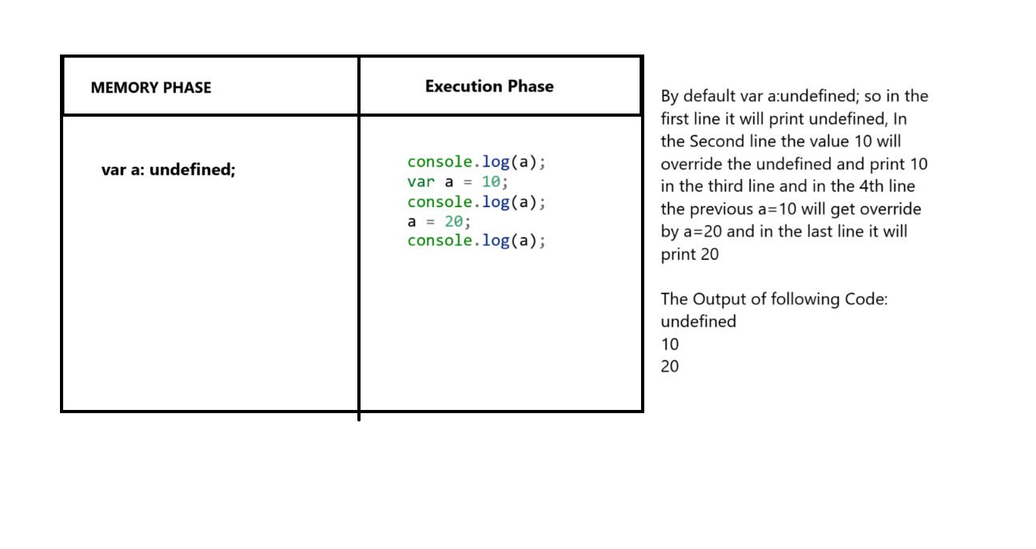

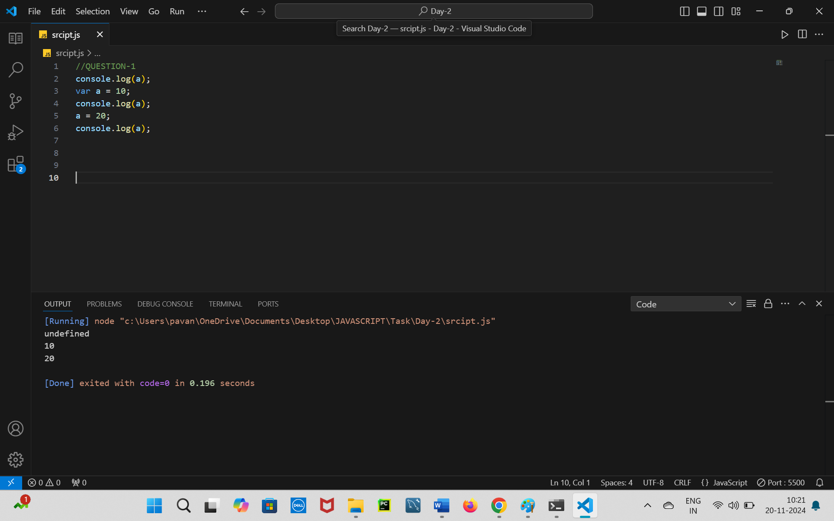

================================================================

console.log(b);  
var b = 5;  
var b = 15;  
console.log(b);  
b = b + 5;  
console.log(b);

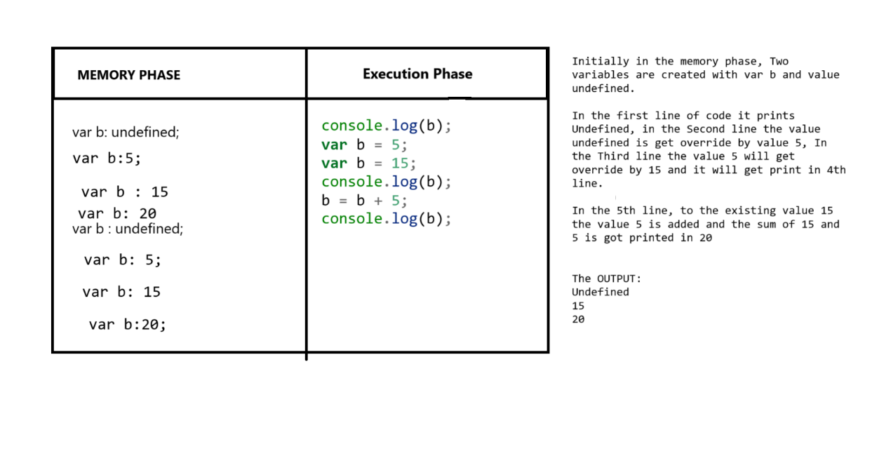

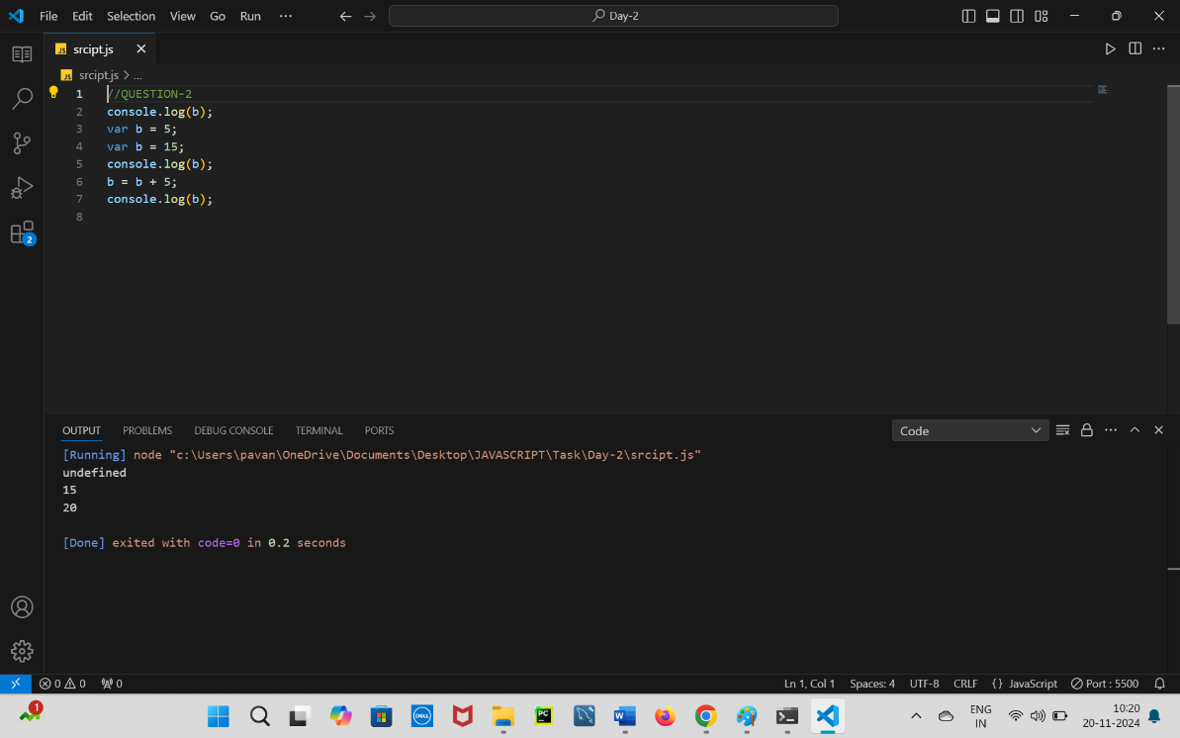

================================================================

console.log(c);  
c = 30;  
var c;  
console.log(c);  
c = c \* 2;  
console.log(c);

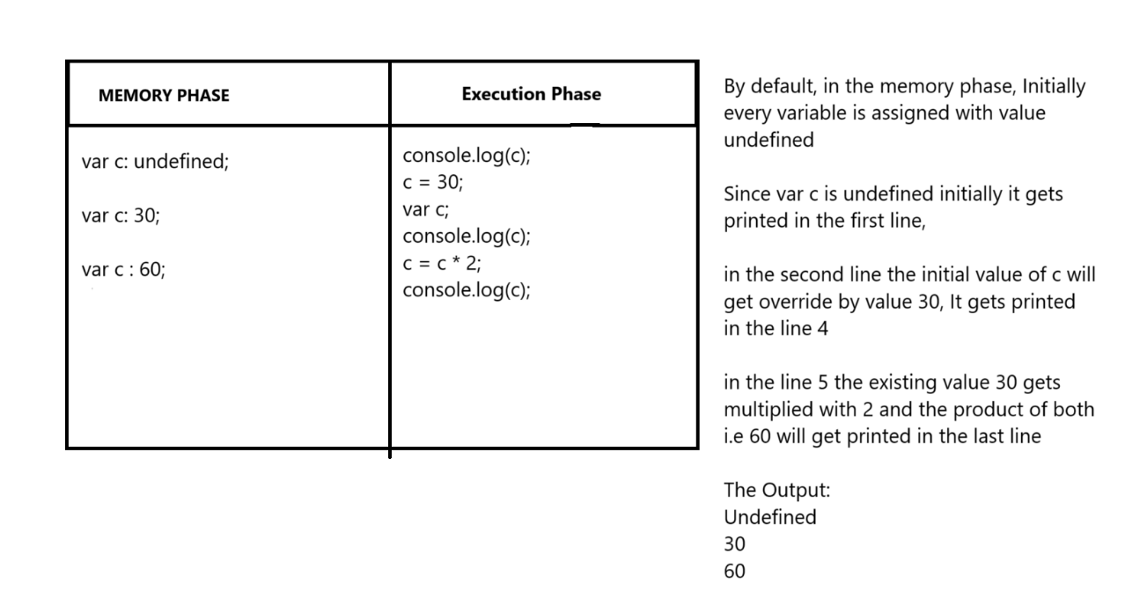

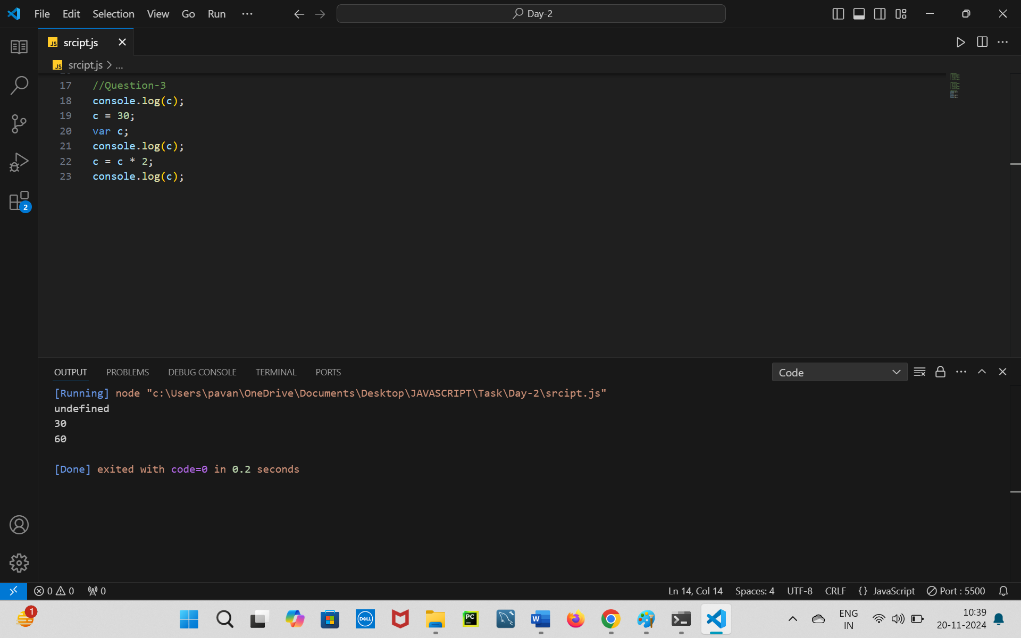

=================================================================

var d;  
console.log(d);  
d = 50;  
console.log(d);  
d = d + 10;  
console.log(d);  
var d = 100;  
console.log(d);

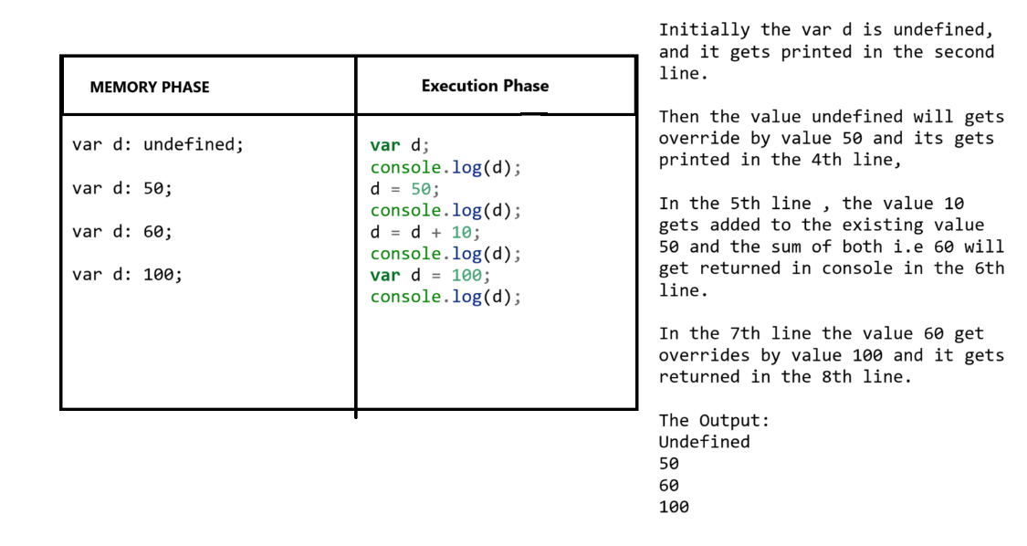

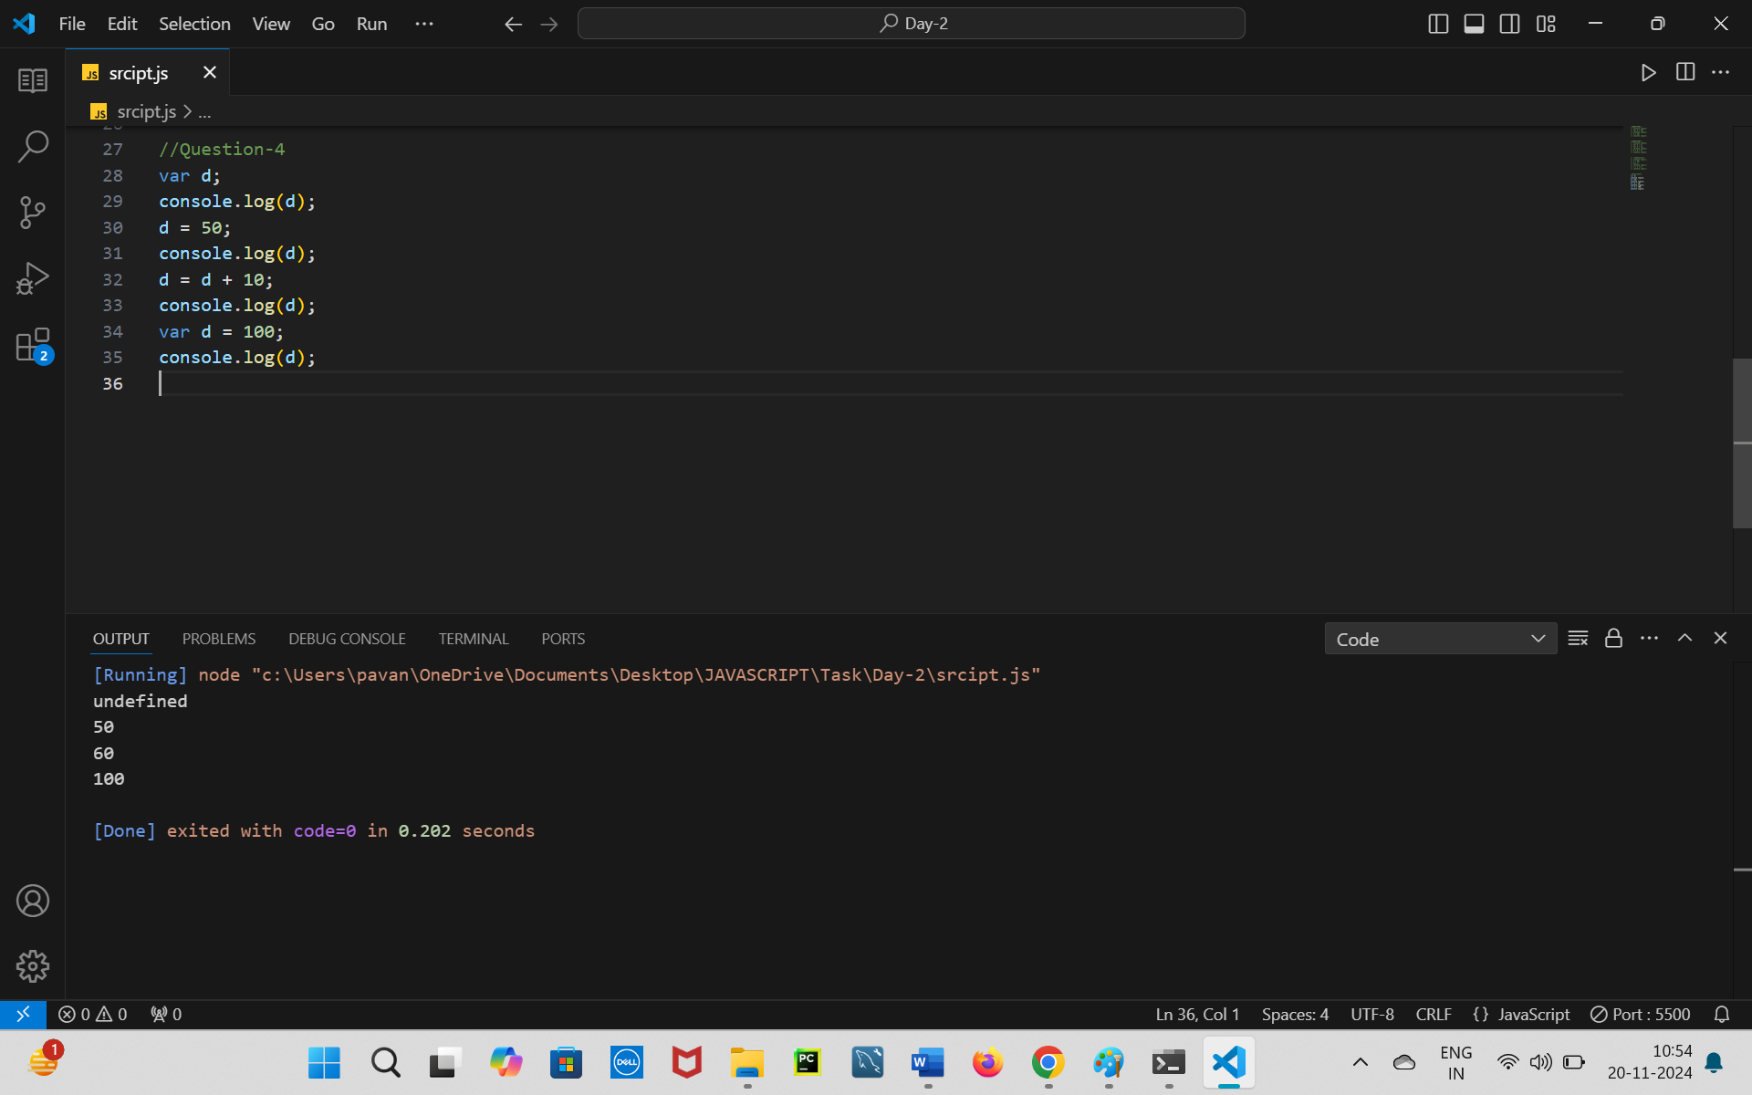

=================================================================

var e = 1;  
console.log(e);  
e = e + 1;  
console.log(e);  
var e = 10;  
console.log(e);  
e = e \* 2;  
console.log(e);

